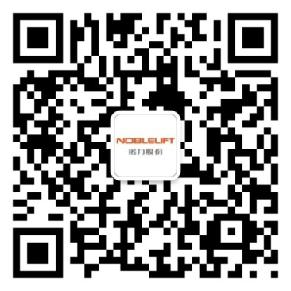

Scan QR Code for More
Service Hotline: 836115
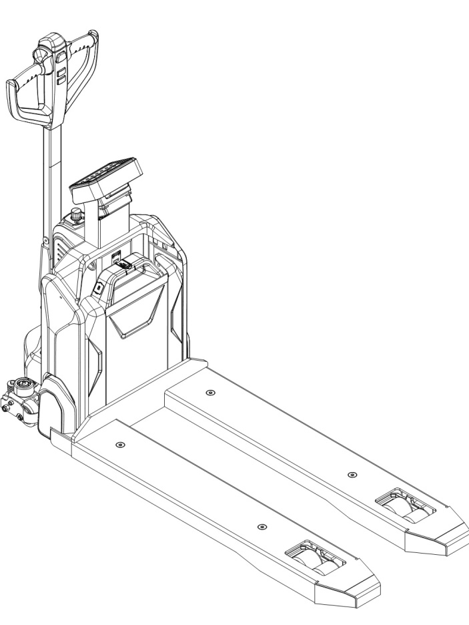

Electric Pallet Truck PTE15N
PARTS MANUAL
508346020101

Version：V01
Truck Identification Number From：
Parts Manual
PTE15N SC-PM01EN

Please order spare parts from authorized dealers of Noblelift Intelligent Equipment Co., LTD.
In order to avoid wrong delivery, all the orders for spare parts should specify the following items:
- Truck model, identification number and manufacture year.
- Orders for spare parts of mast, hydraulic transmission unit, steering axle, motor, etc. shall indicate the manufacture number of these parts.
- Codes for Noblelift spare parts are shown in the table of parts manual. Please also pay attention to the description of supply status, order quantity, etc. (check the number listed in "Mark" column of the parts manual).
"Mark" Column:
The unmarked indicates the parts are in short supply cycle.
Number 1: supply as package. Indicating these that parts are small parts and seal parts, which are supplied in package unit and in short supply cycle.
Number 2: supply with constraints. Indicating that these spare parts are not in stock and will be prepared for production after receiving the order from customers, which are in long supply cycle.
Number 3: phasing-out supply. Indicating that these parts will be replaced by new parts due to technical improvements and the current stock will not be available when these parts run out. Please check the description of technical improvements notice.
Number 4: supply as assembly. Indicating that these parts are assembly parts defined by manufacture process, which cannot be supplied as a single part.
Number 5: check other tables.
This parts manual is the property of Noblelift and can be shared under the confidential agreement only, Noblelift has the right to claim for compensation of any unauthorized use. Copy without permission is not allowed. Figures in the manual are not limited by the original design. Noblelift Intelligent Equipment Co., LTD reserves the right to improve the products for continuous technology progress.

Table of Contents
Chapter 1: Drive System 5
01 Drive Unit Steering（508346013501） 5
01 Drive Unit Steering（508346013501）Continuation 7
02 Drive Assembly（508046013001） 9
Chapter 2: Hydraulic System 11
01 Hydraulic Components（508046023501) 11
Chapter 3: Truck Frame 13
01 Truck Frame (508346038501) 13
01 Truck Frame (508346038501)Continuation 15
02 Truck Frame (508346038502) 17
02 Truck Frame (508346038502)Continuation 19
Chapter 4: Steering System, Braking System, Wheels 21
01 Tiller Unit（508346011001） 21
02 Tiller（508046011002） 23
03 Load Wheel (Tandem)（508346017001） 25
04 Caster（508046016501） 27
05 Caster(without)（508046016502） 29
Chapter 5: Electrical Parts 31
01 Wire Harness (508046033001) 31
02 Controller (508046033002) 33
03 Charger (508046036501) 35
03 Charger (508046036501)Continuation 37
03 Charger (508046036501)Continuation 39
04 Traction Battery (508046037001) 41
05 Indicator holder assembly (508346033501) 43
Chapter 6: Others 45
01 Labels and Decals-EU (508346047001) 45
02 Labels and Decals-US (508346047002) 47
Appendix 49
01 Electrical Circuit Diagram(508046045501) 49
02 Hydraulic Circuit Diagram(508046045502) 50
03 Consumable Parts List 51

Chapter 1: Drive System
01 Drive Unit Steering（508346013501）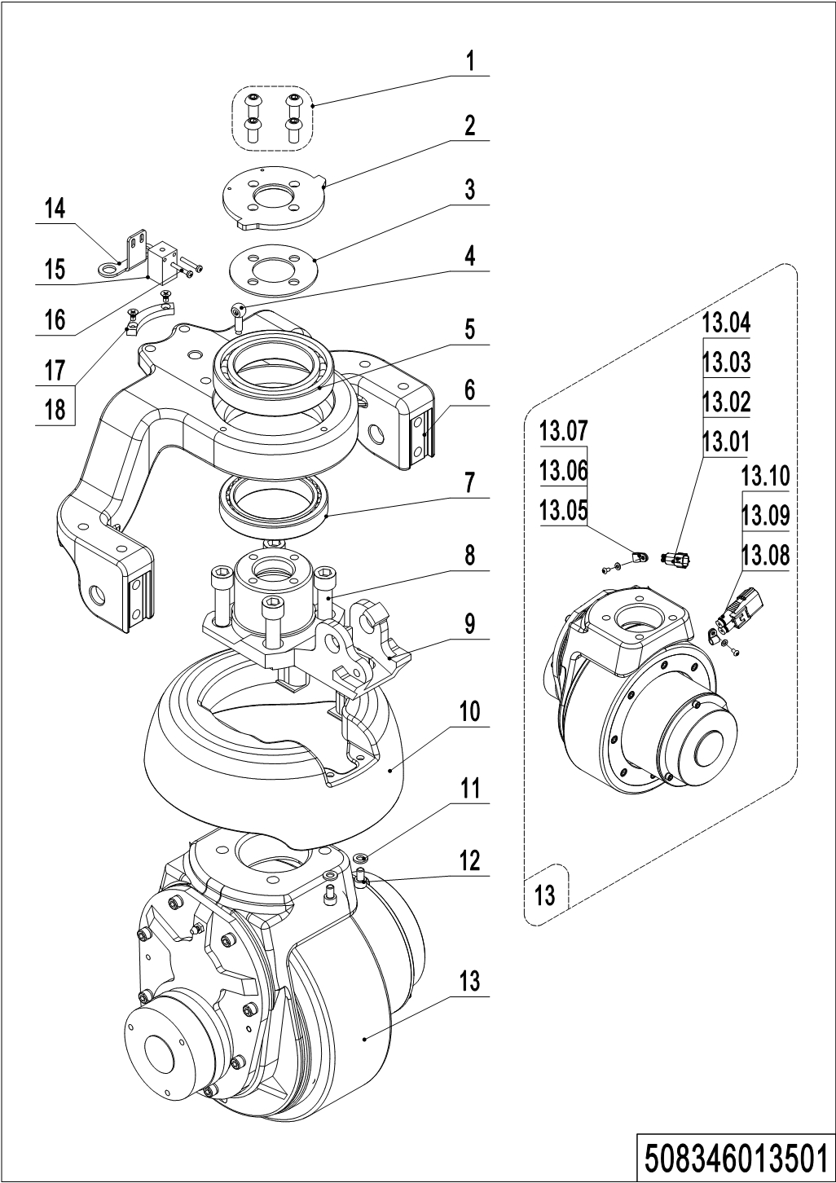
01 Drive Unit Steering (508346013501)
No. | Item Code | Mark | Item Description | Qty. | Substitute | Note
1 | 910200300024 | 1 | Screw | 4
2 | 508013520003 |  | Bearing Plate | 1
3 | 508013520004 |  | Subplate | 1
4 | 910100600001 | 1 | Bolt | 1
5 | 910700200058 | 1 | Bearing | 1
6 | 508013520000 |  | Wheel Mount | 1
7 | 910700600044 |  | Bearing | 1
8 | 910200200076 | 1 | Screw | 4
9 | 508513520000 |  | Flange | 1
10 | 508013520101 |  | Cover | 1 |  | Be sure to color your order
11 | 910400100005 | 1 | Flat Washer | 2
12 | 910200200033 | 1 | Screw | 2
13 | 508098510014 |  | Drive Unit | 1 |  | 6NMPU
13 | 508098510078 |  | Drive Unit | 1 |  | 6NMPU(Water proof)
13 | 508098510052 |  | Drive Unit | 1 |  | 6NMPU Non-slip
13 | 508098510079 |  | Drive Unit | 1 |  | 6NMPU Non-slip (Water proof)
13 | 508098510080 |  | Drive Unit | 1 |  | 8NMPU
13 | 508098510057 |  | Drive Unit | 1 |  | 8NMPU(Water proof)
13 | 508098510081 |  | Drive Unit | 1 |  | 8NMPU Non-slip
13 | 508098510082 |  | Drive Unit | 1 |  | 8NMPU Non-slip (Water proof)
13.01 | 920400200004 | 1 | Connector | 1
13.02 | 920400200003 | 1 | Connector | 1
13.03 | 920400200017 | 1 | Connector | 2
13.04 | 920400200018 | 1 | Connector | 2
13.05 | 910200700001 | 1 | Screw | 2
13.06 | 910400100003 | 1 | Flat Washer | 2
13.07 | 921300200001 |  | Cable Clamp | 2
13.08 | 920400200152 | 1 | Connector | 1
13.08 | 920400200169 | 1 | Connector | 1 |  | Water proof
13.09 | 920400200172 | 1 | Connector | 2

01 Drive Unit Steering（508346013501）Continuation
01 Drive Unit Steering (508346013501) Continuation
No. | Item Code | Mark | Item Description | Qty. | Substitute | Note
13.09 | 920400200150 | 1 | Connector | 2 |  | Water proof
13.10 | 920400200171 | 1 | Connector | 2
14 | 508033020003 |  | Bracket | 1
15 | 920200400017 |  | Proximity Switch | 1
16 | 910200500015 | 1 | Screw | 2
17 | 508033020002 |  | Induction Block | 1
18 | 910200700001 | 1 | Screw | 2

02 Drive Assembly（508046013001）
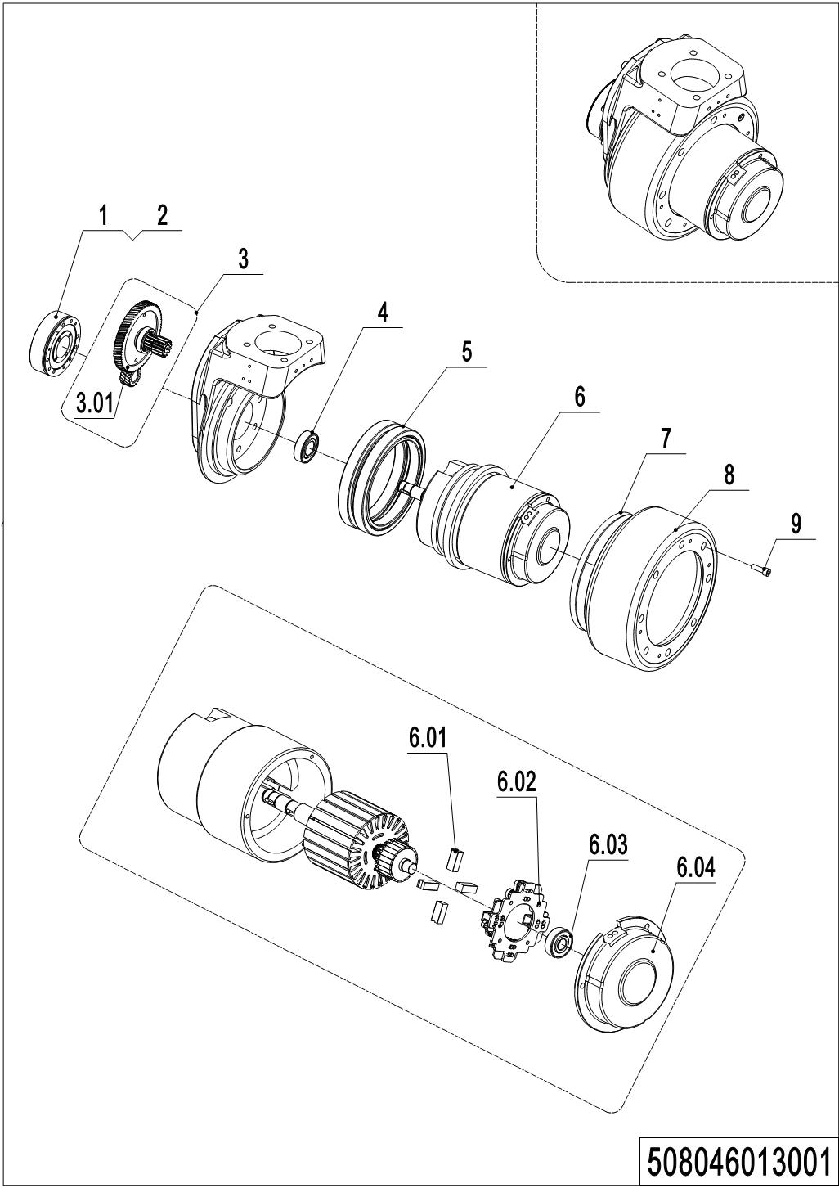
02 Drive Assembly (508046013001)
No. | Item Code | Mark | Item Description | Qty. | Substitute | Note
1 | 508098520002 | 2 | Brake | 1
2 | 508098520040 |  | Rubber Strip | 1
3 | 508098510015 | 2 | Gear Components | 1
3.01 | 508098520004 |  | Gear | 1
4 | 910700200004 |  | Bearing | 1
5 | 508098520011 | 2 | Gear Ring | 1
6 | 508098510016 | 2 | Motor | 1
6.01 | 508098520000 | 2 | Carbon Brush | 4
6.02 | 508098520001 | 2 | Carbon Brush Holder | 1
6.03 | 910700200016 |  | Bearing | 1
6.04 | 508098520036 | 2 | End Cap | 1
7 | 508098520032 |  | Seal | 1
8 | 508098520003 |  | Wheel | 1
9 | 910200200167 |  | Screw Kits | 8

Chapter 2: Hydraulic System

01 Hydraulic Components（508046023501) 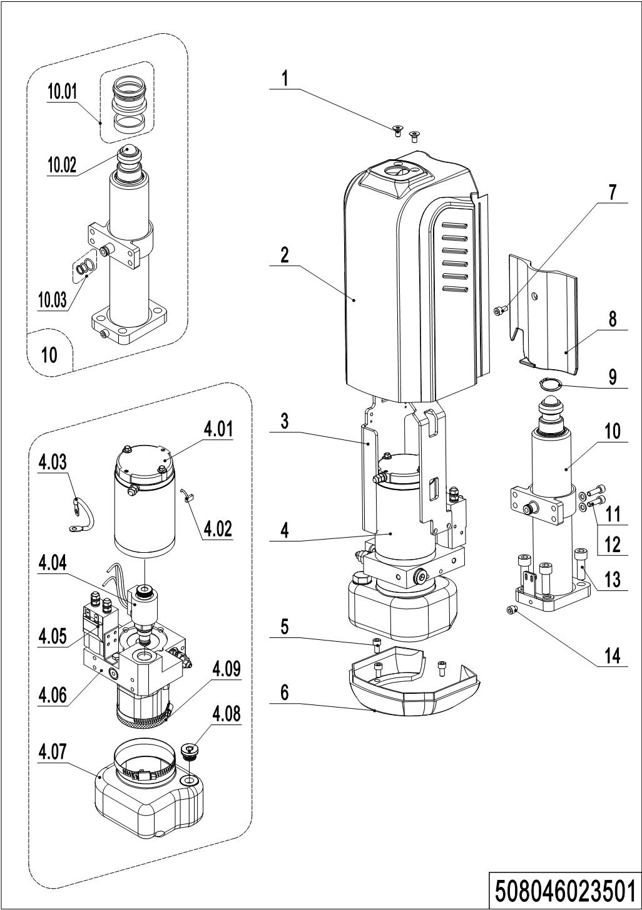
01 Hydraulic Components (508046023501)
No. | Item Code | Mark | Item Description | Qty. | Substitute | Note
1 | 910200400015 | 1 | Screw | 2
2 | 508024020101 |  | Cover | 1 |  | Be sure to color your order
3 | 508024010002 |  | Mounting Rack | 1
4 | 950900100060 |  | Pump Unit | 1
4.01 | 508098510020 | 2 | Motor | 1
4.02 | 508098520008 | 2 | Brush | 1
4.03 | 508098520007 | 2 | Cables | 1
4.04 | 508098510034 | 2 | Magnetic Valve | 1
4.05 | 508098510021 | 2 | Switch | 1
4.06 | 508098510053 | 2 | Gear Pump | 1
4.07 | 508098510023 | 2 | Tank Kit | 1
4.08 | 508598510009 | 2 | Filter | 1
4.09 | 508098520037 | 2 | Filter | 1
5 | 910200200033 | 1 | Screw | 3
6 | 508024020102 |  | Shield | 1 |  | Be sure to color your order
7 | 910200200171 | 1 | Screw | 1
8 | 508024020103 |  | Cover | 1
9 | 910401300017 | 1 | Circlip | 1
10 | 508024010003 |  | Cylinder | 1
10.01 | 508098510018 |  | Seal Kit | 1
10.02 | 910701100019 |  | Steel Ball | 1
10.03 | 508598510004 |  | Seal Kit | 1
11 | 910200200036 | 1 | Screw | 7
12 | 910400100005 | 1 | Flat Washer | 7
13 | 910200200077 | 1 | Screw | 4
14 | 910200200160 | 1 | Screw | 1

Chapter 3: Truck Frame

01 Truck Frame (508346038501)
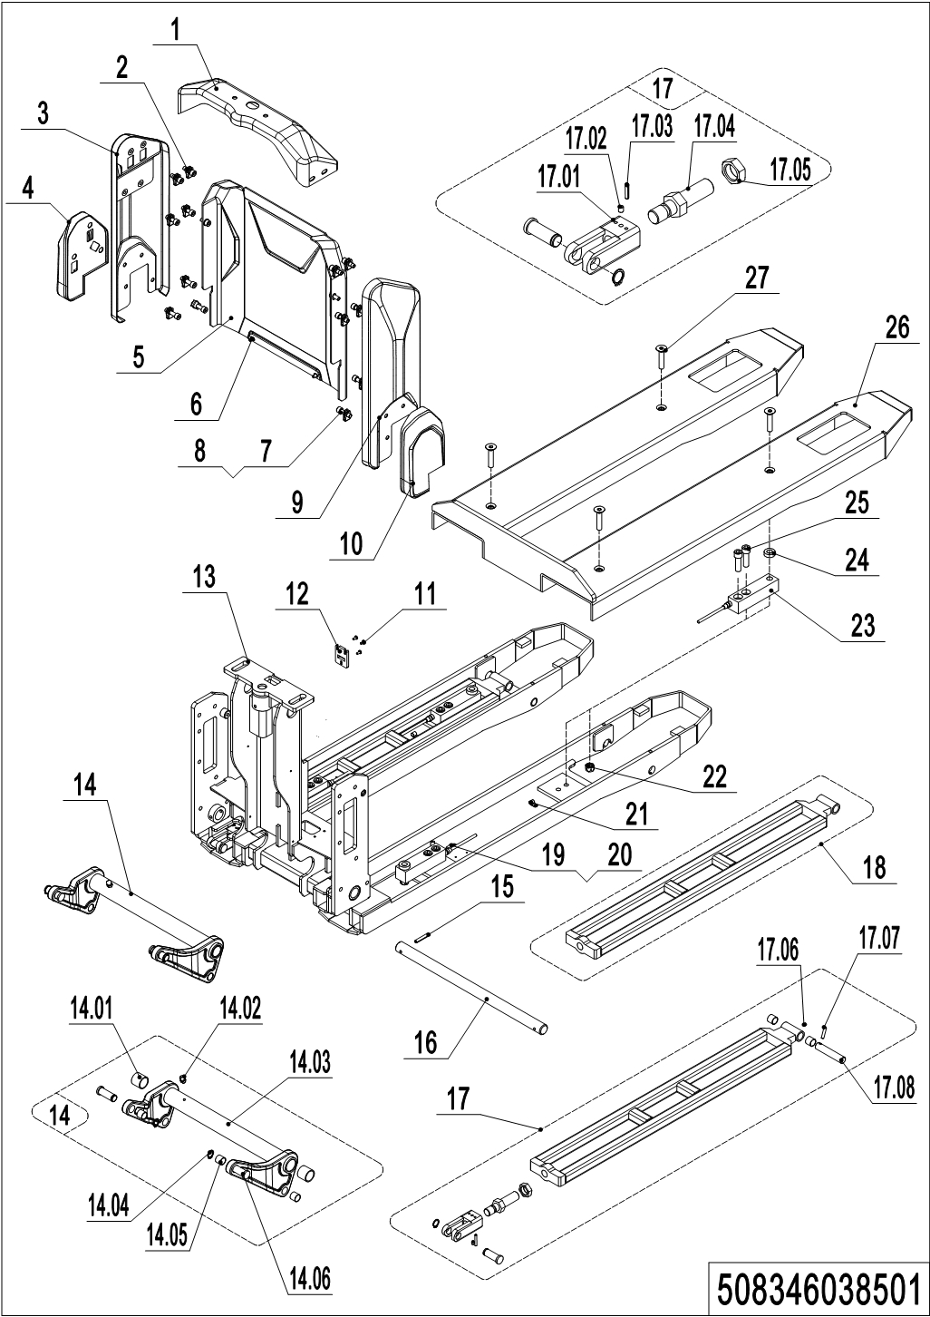
01 Truck Frame (508346038501)
No. | Item Code | Mark | Item Description | Qty. | Substitute | Note
1 | 508338520020 |  | Cover | 1 |  | Be sure to color your order
2 | 910200200156 | 1 | Screw | 4
3 | 508038510100 |  | Side cover(left) | 1 |  | Be sure to color your order
4 | 508038510102 |  | Side Cover(left 540) | 1 |  | Be sure to color your order
5 | 508038520111 |  | Front Panel | 1 |  | Be sure to color your order
6 | 910200500051 | 1 | Screw | 2
7 | 940400400002 |  | Cage Nut | 14
8 | 910200200157 | 1 | Screw | 10
9 | 508038510101 |  | Side cover(right) | 1 |  | Be sure to color your order
10 | 508038510103 |  | Side Cover(right 540) | 1 |  | Be sure to color your order
11 | 508038520109 |  | Lock | 1
12 | 910200500034 | 1 | Screw | 3
13 | 508338510001 | 2 | Chassis (562x1150) | 1
14 | 508098510001 |  | Rise Arm | 1
14.01 | 940500100097 |  | Bushing | 2
14.02 | 911200100002 |  | Oil Cup | 1
14.03 | 508038510010 |  | Rise Arm | 1
14.04 | 910401300007 |  | Circlip | 4
14.05 | 940500100083 |  | Bushing | 8
14.06 | 508038520041 |  | Pin | 4
15 | 910600400041 | 1 | Spring Pin | 2
16 | 508038520027 |  | Axle | 1
17 | 508098510002 |  | Push Rod Kit(1150) | 2
17.01 | 508038520028 |  | Push Rod Fork | 2
17.02 | 910201000005 | 1 | Screw | 2
17.03 | 910600500001 | 1 | Spring Pin | 4
17.04 | 508038520029 |  | Threaded Rod | 2
17.05 | 910300400008 | 1 | Nut | 2
17.06 | 911200100001 | 1 | Oil Cup | 2
17.07 | 910600400024 | 1 | Spring Pin | 2

01 Truck Frame (508346038501)Continuation
01 Truck Frame (508346038501) Continuation
No. | Item Code | Mark | Item Description | Qty. | Substitute | Note
17.08 | 502338520030 |  | Axle | 2
18 | 508338510002 | 2 | Push Rod Kit (1150) | 2
19 | 302871620049 |  | Press Plate | 2
20 | 910200500021 |  | Screw | 14
21 | 921300200001 | 10 | Cable Clamp | 10
22 | 910300500006 |  | Nut | 4
23 | 921800100031 |  | Sensor | 4
24 | 302871620048 |  | Washer | 4
25 | 910200200100 |  | Screw | 8
26 | 508338510000 |  | Fork | 1
27 | 941100300004 |  | Screw | 4

02 Truck Frame (508346038502)
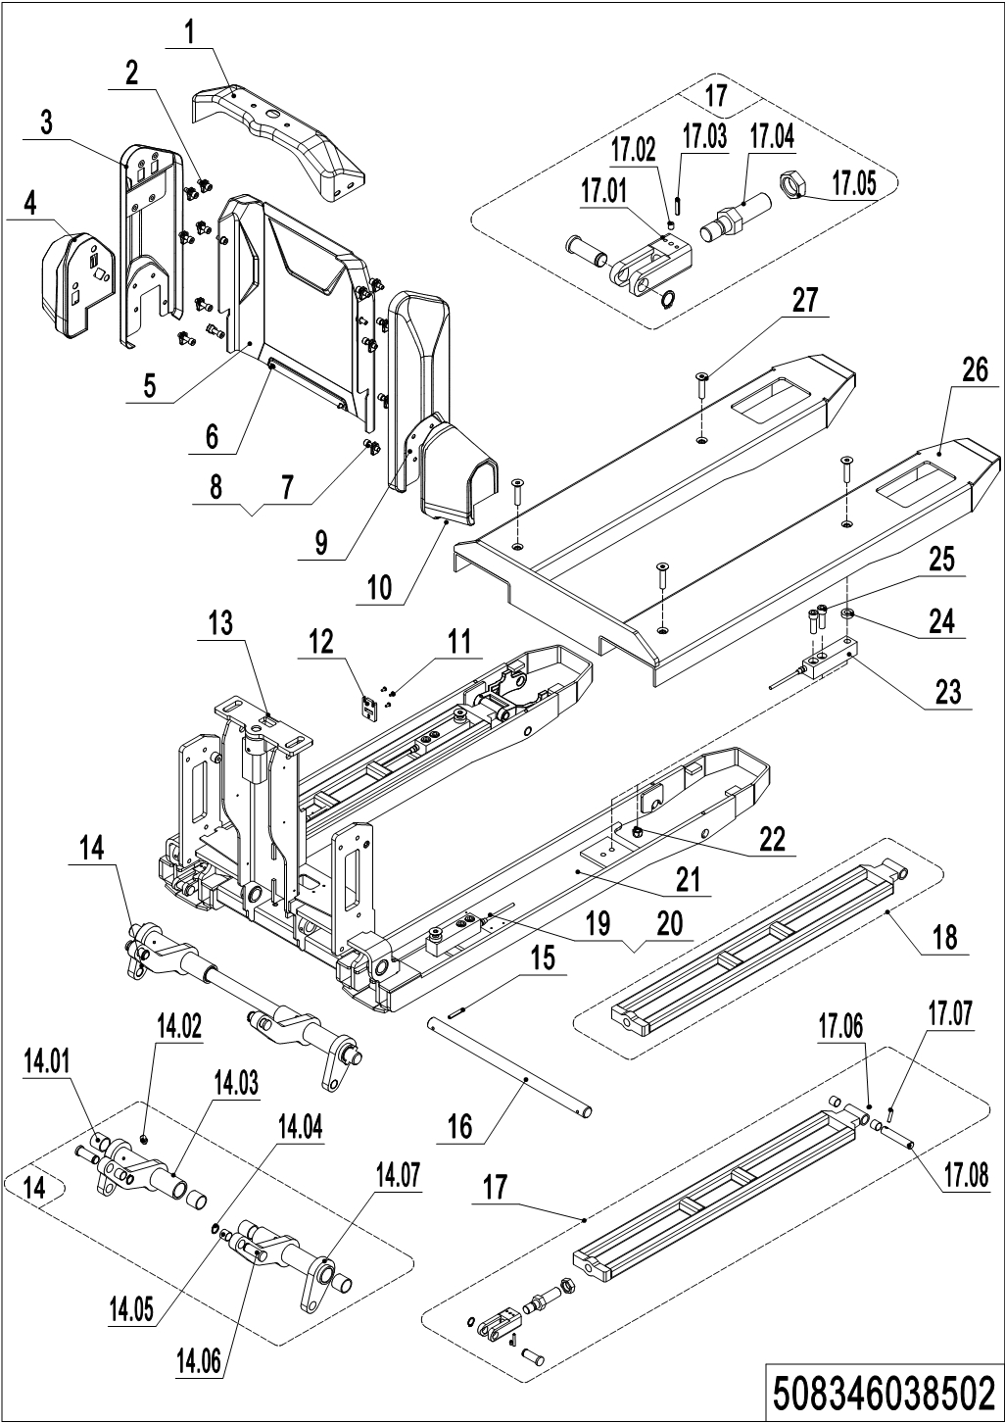
02 Truck Frame (508346038502)
No. | Item Code | Mark | Item Description | Qty. | Substitute | Note
1 | 508338520020 |  | Cover | 1 |  | Be sure to color your order
2 | 910200200156 | 1 | Screw | 4
3 | 508038510100 |  | Side cover(left) | 1 |  | Be sure to color your order
4 | 508038510104 |  | Side Cover(left 685) | 1 |  | Be sure to color your order
5 | 508038520111 |  | Front Panel | 1 |  | Be sure to color your order
6 | 910200500051 | 1 | Screw | 2
7 | 940400400002 |  | Cage Nut | 14
8 | 910200200157 | 1 | Screw | 10
9 | 508038510101 |  | Side cover(right) | 1 |  | Be sure to color your order
10 | 508038510105 |  | Side Cover(right 685) | 1 |  | Be sure to color your order
11 | 508038520109 |  | Lock | 1
12 | 910200500034 | 1 | Screw | 3
13 | 508338510003 | 2 | Chassis (707x1150) | 1
14 | 508098510003 |  | Rise Arm | 1
14.01 | 940500100097 |  | Bushing | 2
14.02 | 911200100002 | 1 | Oil Cup | 2
14.03 | 508038510012 |  | Rise Arm | 1
14.04 | 910401300007 |  | Circlip | 4
14.05 | 940500100083 |  | Bushing | 8
14.06 | 508038520041 |  | Pin | 4
14.07 | 508038510013 |  | Rise Arm | 1
15 | 910600400041 | 1 | Spring Pin | 2
16 | 508038520035 |  | Axle | 1
17 | 508098510002 |  | Push Rod Kit(1150) | 2
17.01 | 508038520028 |  | Push Rod Fork | 2
17.02 | 910201000005 | 1 | Screw | 2
17.03 | 910600500001 | 1 | Spring Pin | 4
17.04 | 508038520029 |  | Threaded Rod | 2
17.05 | 910300400008 | 1 | Nut | 2
17.06 | 911200100001 | 1 | Oil Cup | 2

02 Truck Frame (508346038502)Continuation
02 Truck Frame (508346038502) Continuation
No. | Item Code | Mark | Item Description | Qty. | Substitute | Note
17.07 | 910600400024 | 1 | Spring Pin | 2
17.08 | 502338520030 |  | Axle | 2
18 | 508338510002 | 2 | Push Rod Kit (1150) | 2
19 | 302871620049 |  | Press Plate | 2
20 | 910200500021 |  | Screw | 14
21 | 921300200001 | 10 | Cable Clamp | 10
22 | 910300500006 |  | Nut | 4
23 | 921800100031 |  | Sensor | 4
24 | 302871620048 |  | Washer | 4
25 | 910200200100 |  | Screw | 8
26 | 508338510000 |  | Fork | 1
27 | 941100300004 |  | Screw | 4

Chapter 4: Steering System, Braking System, Wheels
01 Tiller Unit（508346011001）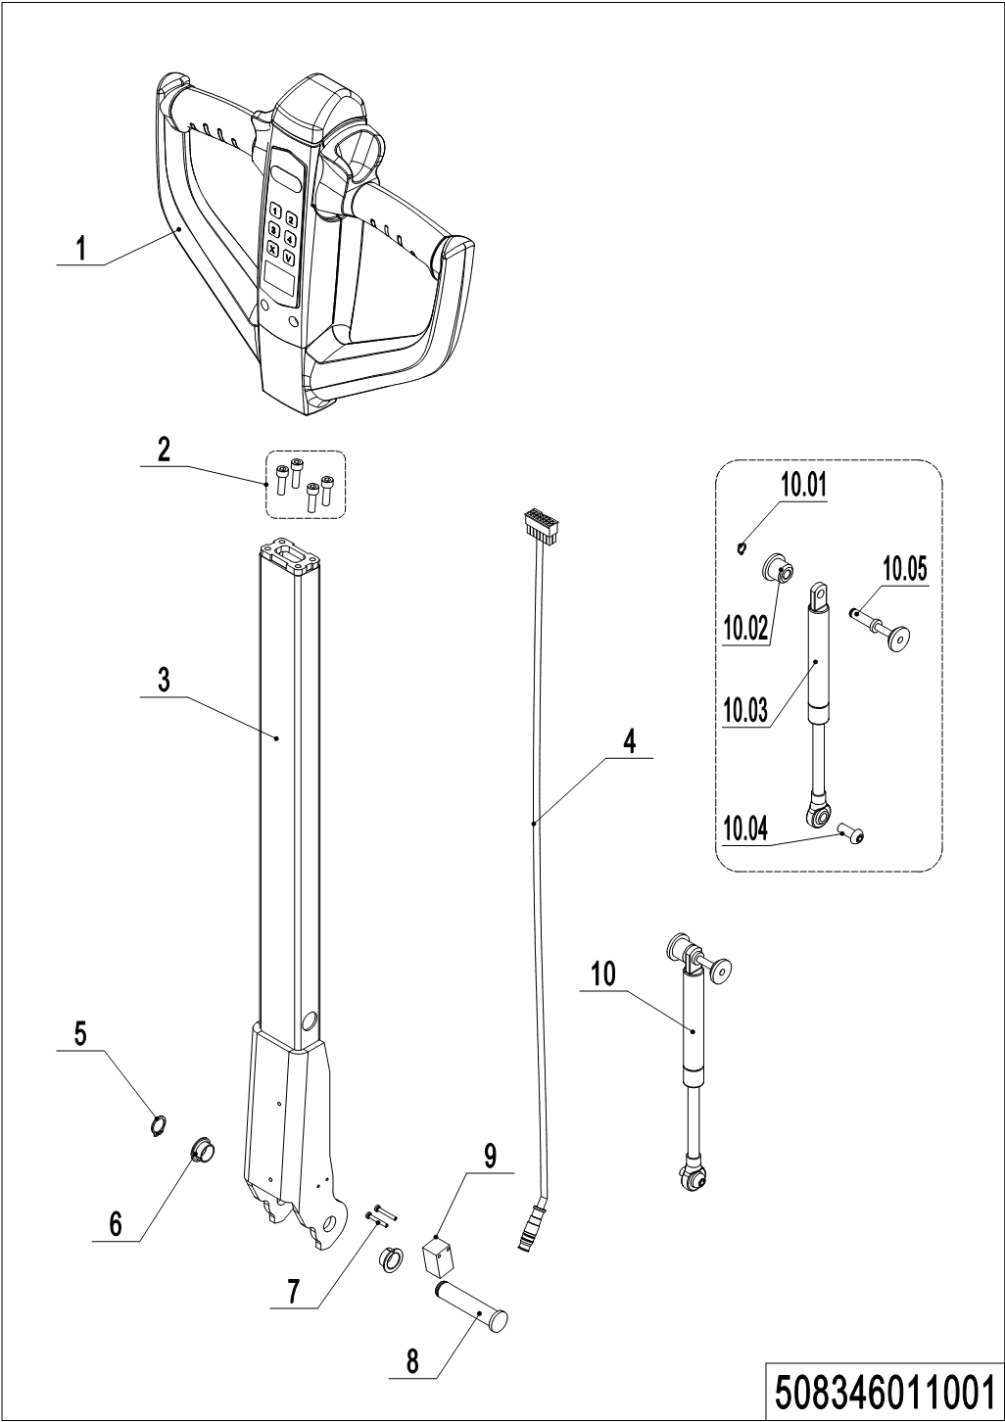
01 Tiller Unit（508346011001）
No. | Item Code | Mark | Item Description | Qty. | Substitute | Note
1 | 922100100013 |  | Tiller | 1
1 | 922100100019 |  | Tiller | 1 |  | IC Card
2 | 910200200036 | 1 | Screw | 4
3 | 508311010000 |  | Tiller | 1
4 | 508033010001 |  | Wire Harness | 1
5 | 910401300006 |  | Circlip | 1
6 | 940500200001 |  | Bushing | 2
7 | 941101100001 | 1 | Screw | 2
8 | 508011020004 |  | Pin | 1
9 | 508033010011 | 3 | Proximity Switch | 1 | 920200400027
9 | 920200400027 |  | Proximity Switch | 1
10 | 508098510084 |  | Gas Spring Kit | 1
10.1 | 910401300001 |  | Circlip | 1
10.2 | 508011020005 |  | Fixing Base | 1
10.3 | 508011010001 |  | Gas Spring | 1
10.4 | 941100100011 | 1 | Screw | 1
10.5 | 508011010002 |  | Pin | 1

02 Tiller（508046011002）
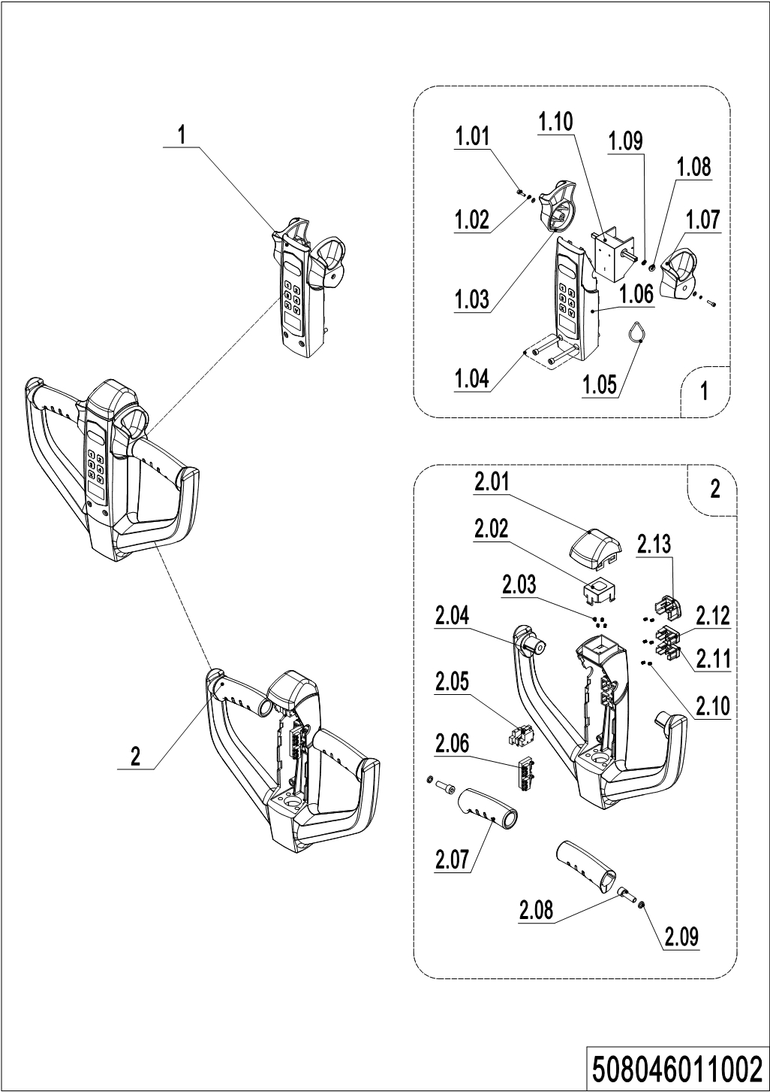
02 Tiller（508046011002）
No. | Item Code | Mark | Item Description | Qty. | Substitute | Note
1 | 508098510032 |  | Handle Cap Kit | 1 |  | Be sure to color your order
1 | 508098510056 |  | Handle Cap Kit | 1 |  | Be sure to color your order
1.01 | 910200200003 | 1 | Screw | 2
1.02 | 910400500002 | 1 | Spring Washer | 2
1.03 | 508098520014 |  | Traction lever | 1
1.04 | 910200200159 | 1 | Screw | 2
1.05 | 508098520027 |  | ID Card | 1 |  | With a swipe function
1.06 | 508098510039 |  | Display Screen kit | 1
1.07 | 508098520020 |  | Traction lever | 1
1.08 | 508098520015 |  | Bushing | 2
1.09 | 508098520016 |  | Bushing | 2
1.10 | 508098510028 |  | Accelerator | 1
1.10 | 508098510055 |  | Accelerator | 1 |  | IC Card
2 | 508098510031 |  | Handle Cap Kit | 1 |  | Be sure to color your order
2.01 | 508098520018 |  | Cap,Break Switch | 1
2.02 | 508098520019 |  | Bracket | 1
2.03 | 502311020018 |  | Spring | 4
2.04 | 508098520012 |  | Handle Cap | 1 |  | Be sure to color your order
2.05 | 508098510029 |  | Microswitch Kits | 1
2.06 | 508098510030 |  | Microswitch Kits | 1
2.07 | 508098520013 |  | Handle | 2 |  | Be sure to color your order
2.08 | 910200200058 | 1 | Screw | 2
2.09 | 910400500006 | 1 | Spring Washer | 2
2.10 | 502311020022 |  | Spring | 6
2.11 | 508098520031 |  | Button | 1 |  | Be sure to color your order
2.12 | 508098520030 |  | Button | 1 |  | Be sure to color your order
2.13 | 508098520029 |  | Horn Button | 1 |  | Be sure to color your order

03 Load Wheel (Tandem)（508346017001）
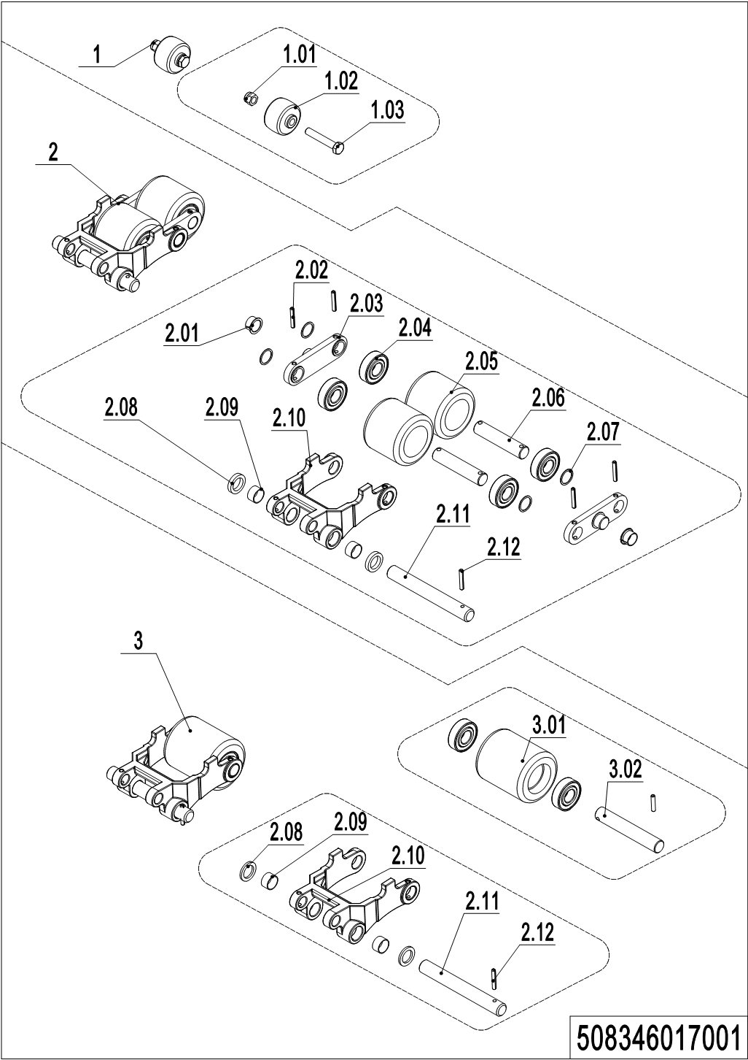
03 Load Wheel (Tandem)（508346017001）
No. | Item Code | Mark | Item Description | Qty. | Substitute | Note
1 | 502398510003 |  | Pulley components | 2
1.01 | 910300500005 | 1 | Nut | 2
1.02 | 505638520039 |  | Running Pulley | 2
1.03 | 941100200019 | 1 | Bolt | 2
2 | 508098510049 |  | Wheel | 2
2.01 | 940500200038 |  | Bushing | 4
2.02 | 910600400027 | 1 | Spring Pin | 8
2.03 | 502317020000 |  | Plate | 4
2.04 | 910700200019 |  | Bearing | 8/4 |  | Double / single
2.05 | 940300300005 |  | WheelΦ80x70 | 4
2.06 | 502317020001 |  | Axle | 4
2.07 | 940600500013 |  | Washer | 8/4 |  | Double / single
2.08 | 502338520033 |  | Roller | 4
2.09 | 940500100088 |  | Bushing | 4
2.10 | 508038520110 |  | Riser | 2
2.11 | 502338520031 |  | Pin | 2
2.12 | 910600400025 |  | Spring Pin | 2
3 | 508098510050 |  | Wheel | 2
3.01 | 940300300023 |  | WheelΦ80x93 | 2
3.02 | 301017020001 |  | Axle | 2

04 Caster（508046016501）
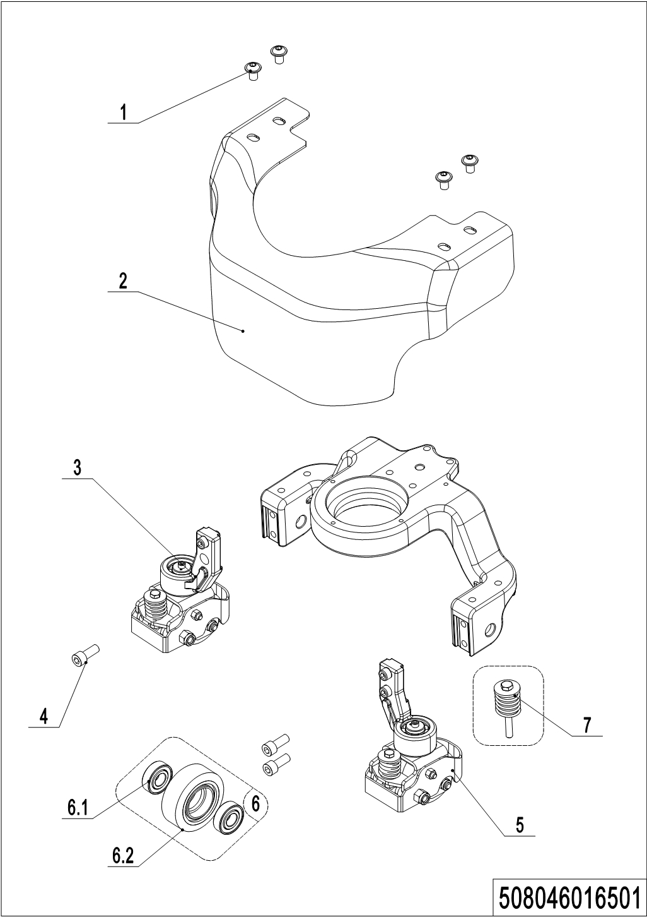
04 Caster（508046016501）
No. | Item Code | Mark | Item Description | Qty. | Substitute | Note
1 | 941100100005 | 1 | Screw | 4
2 | 508016520000 |  | Apron | 1 |  | 35 mm off the ground
2 | 508016520008 |  | Apron | 1 |  | 45 mm off the ground
3 | 508016510002 |  | Caster Assembly | 1
4 | 910200200076 | 1 | Screw | 4
5 | 508016510005 |  | Caster Assembly | 1
6 | 502398510015 | 2 | Load Wheel Kit | 2
6.1 | 910700200018 |  | Bearing | 4
6.2 | 940300300017 |  | WheelΦ80x30 | 2
7 | 508098510047 |  | Spring Components | 2

05 Caster(without)（508046016502）
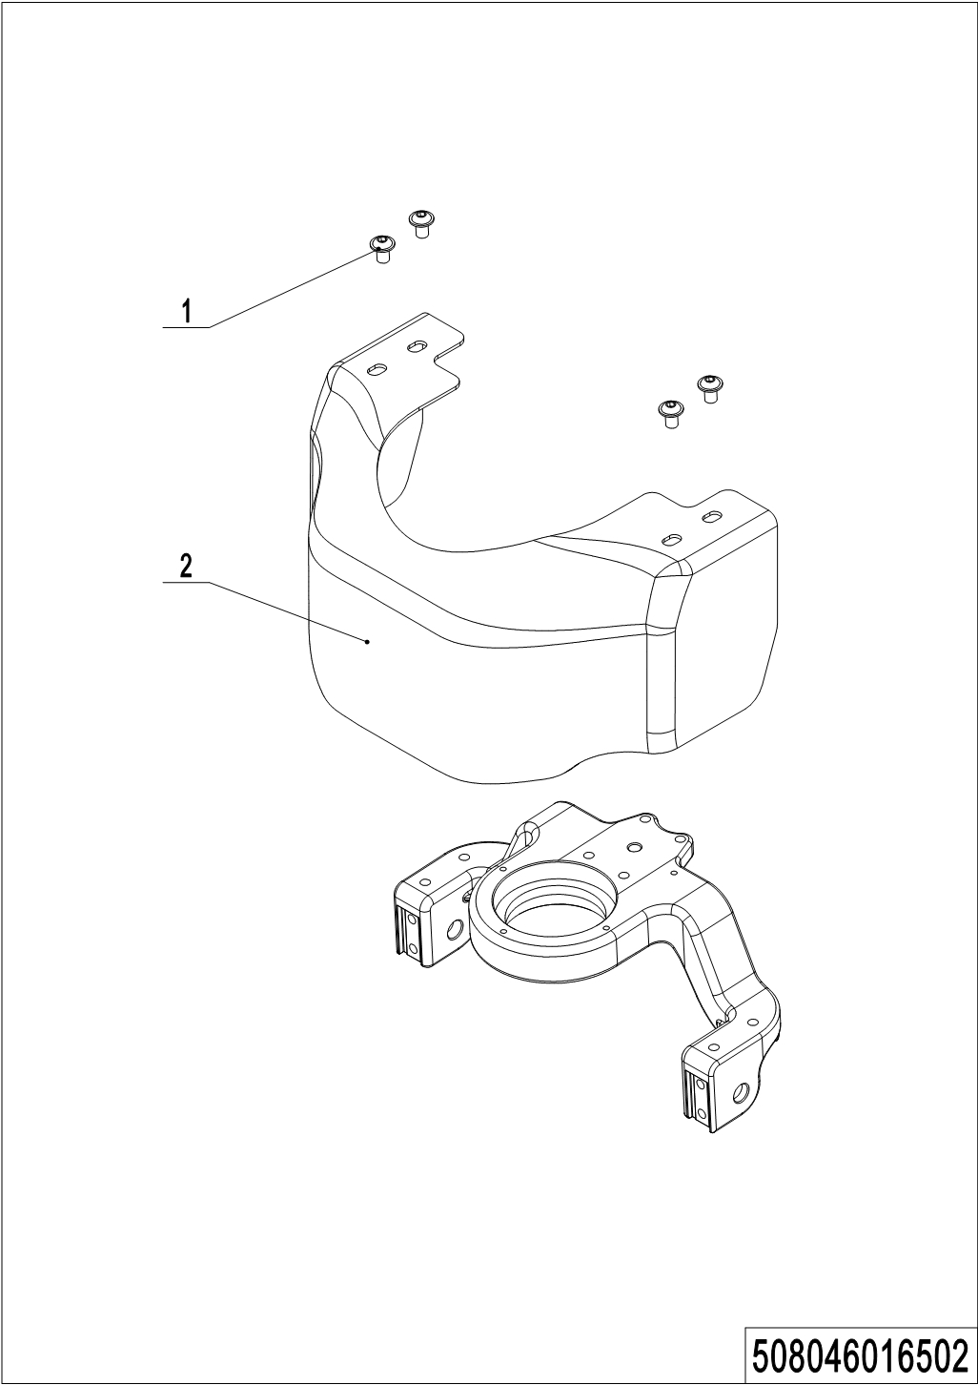
05 Caster(without）（508046016502）
No. | Item Code | Mark | Item Description | Qty. | Substitute | Note
1 | 941100100005 | 1 | Screw | 4
2 | 508016520001 |  | Apron | 1 |  | 35 mm off the ground
2 | 508016520009 |  | Apron | 1 |  | 45 mm off the ground

Chapter 5: Electrical Parts

01 Wire Harness (508046033001) 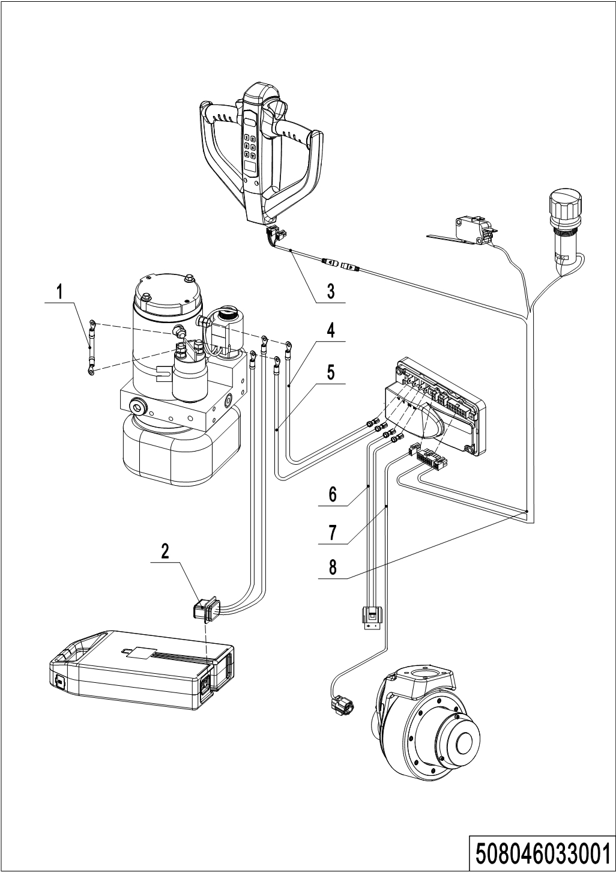
01 Wire Harness (508046033001)
No. | Item Code | Mark | Item Description | Qty. | Substitute | Note
1 | 508033010010 |  | Wire Harness | 1
2 | 508033010003 |  | Wire Harness | 1
3 | 508033010001 |  | Wire Harness | 1
4 | 508033010005 |  | Wire Harness | 1
5 | 508033010004 |  | Wire Harness | 1
6 | 508033010006 |  | Wire Harness | 1
6 | 508033010018 |  | Wire Harness | 1
7 | 508033010007 |  | Wire Harness | 1
8 | 508033010000 |  | Wire Harness | 1
8 | 508033010009 |  | Wire Harness | 1

02 Controller (508046033002)
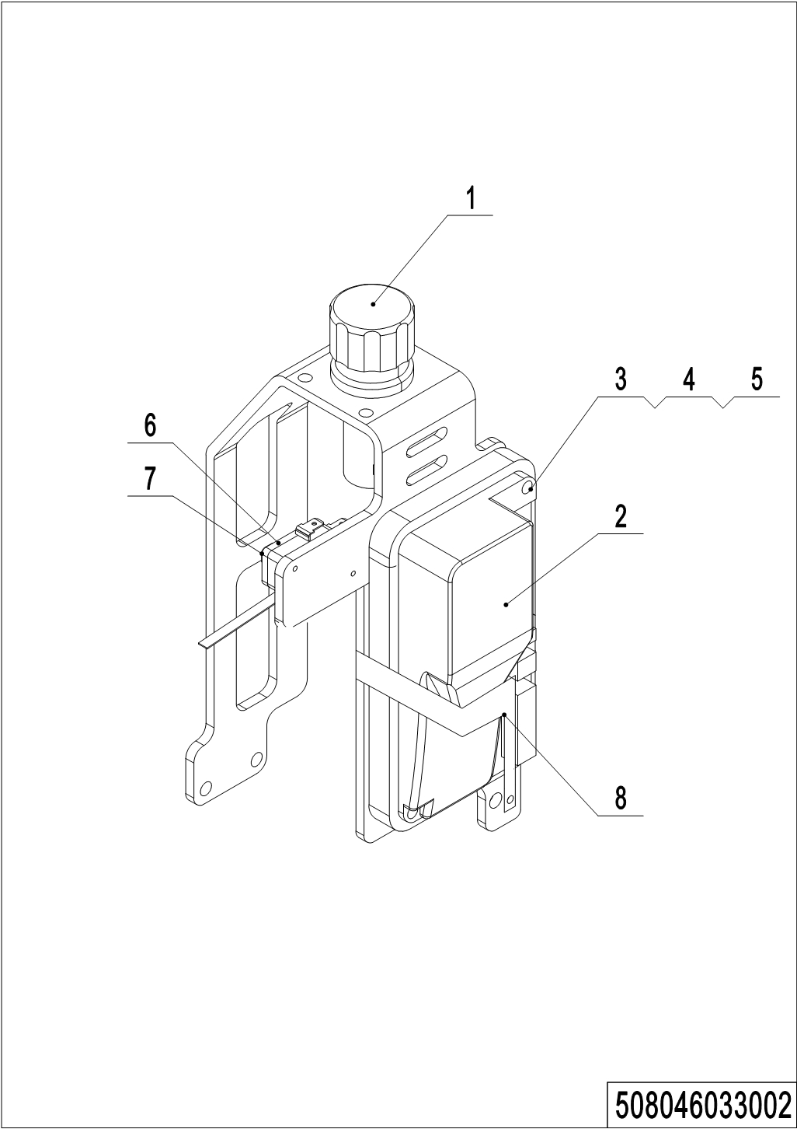
02 Controller (508046033002)
No. | Item Code | Mark | Item Description | Qty. | Substitute | Note
1 | 920200100015 |  | Emergency Button | 1
2 | 921400100081 |  | Controller | 1
3 | 910400100004 | 1 | Flat Washer | 2
4 | 910400500004 | 1 | Spring Washer | 2
5 | 910200200025 | 1 | Screw | 2
6 | 505698520008 | 1 | Screw | 2
7 | 920200300012 |  | Microswitch | 1
8 | 508033020000 |  | Bracket | 1

03 Charger (508046036501)
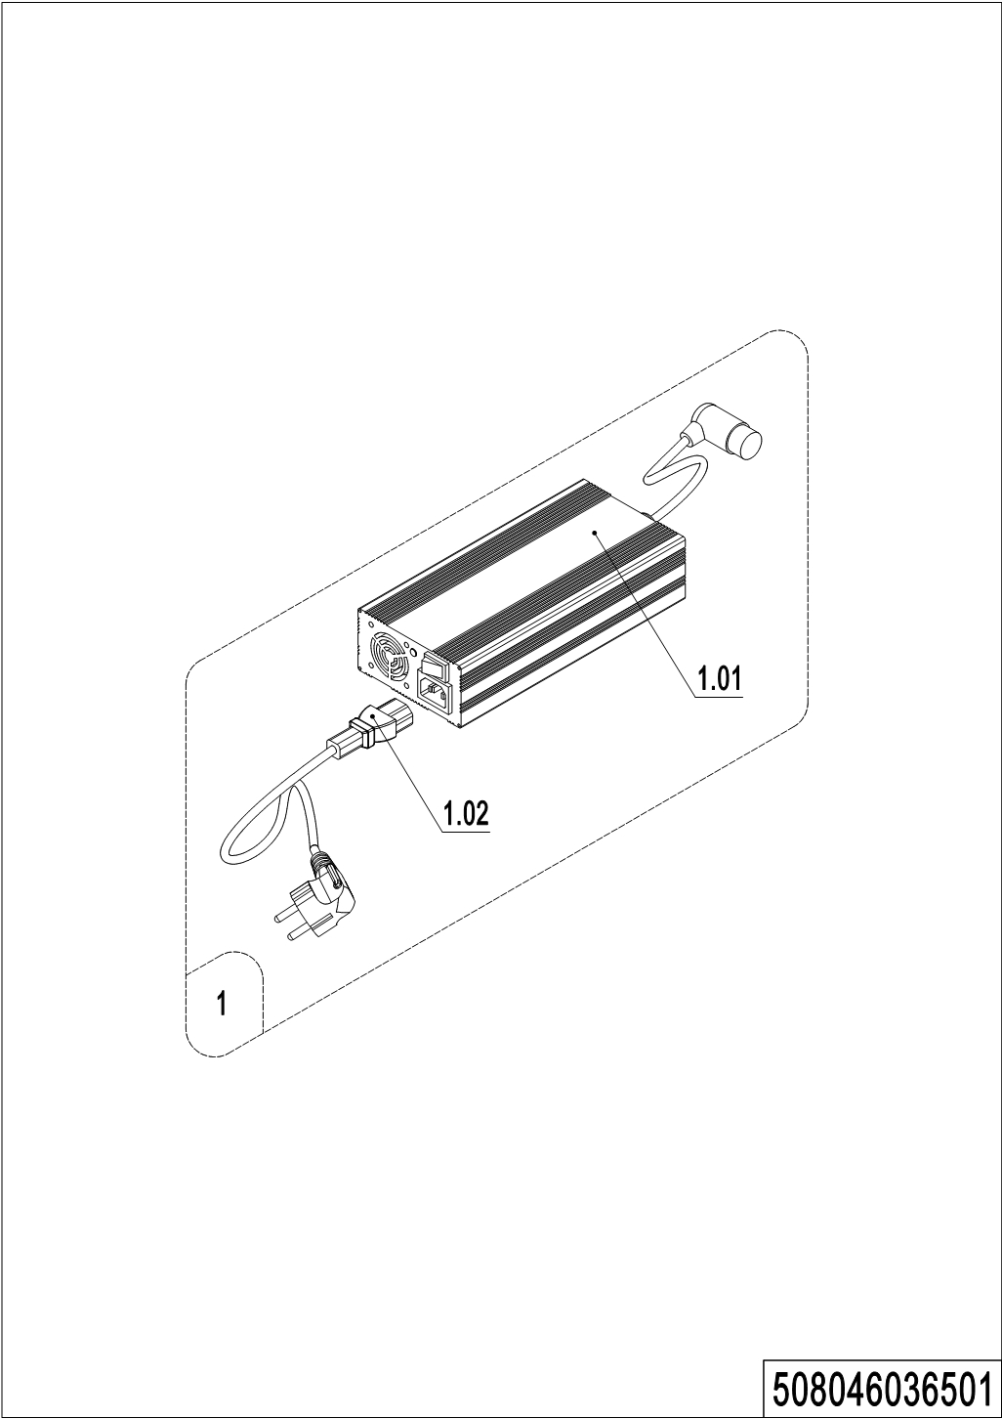
03 Charger (508046036501)
No. | Item Code | Mark | Item Description | Qty. | Substitute | Note
1 | 508036510013 |  | charger24V12A(Asia) | 1 |  | QQE
1 | 508036510014 |  | charger24V12A(ENG) | 1 |  | QQE
1 | 508036510015 |  | charger24V12A(US) | 1 |  | QQE
1 | 508036510016 |  | charger24V12A(EU) | 1 |  | QQE
1 | 508036510017 |  | charger24V12A(AUS) | 1 |  | QQE
1 | 508036510018 |  | charger24V12A(ITA) | 1 |  | QQE
1 | 508036510019 |  | charger24V12A(SWE) | 1 |  | QQE
1 | 508036510020 |  | charger24V12A(ISR) | 1 |  | QQE
1 | 508036510021 |  | charger24V12A(BRA) | 1 |  | QQE
1 | 508036510022 |  | charger24V12A(ARG) | 1 |  | QQE
1 | 508036510038 |  | charger24V12A(ZA) | 1 |  | QQE
1 | 508036510037 |  | charger24V12A(IND) | 1 |  | QQE
1 | 508036510041 |  | Lithium charger 24V12A(Asia) | 1 |  | WT
1 | 508036510042 |  | Lithium charger 24V12A(ENG) | 1 |  | WT
1 | 508036510043 |  | Lithium charger 24V12A(US) | 1 |  | WT
1 | 508036510044 |  | Lithium charger 24V12A(EU) | 1 |  | WT
1 | 508036510045 |  | Lithium charger 24V12A(AUS) | 1 |  | WT
1 | 508036510046 |  | Lithium charger 24V12A(ITA) | 1 |  | WT
1 | 508036510047 |  | Lithium charger 24V12A(SWE) | 1 |  | WT
1 | 508036510048 |  | Lithium charger 24V12A(ISR) | 1 |  | WT
1 | 508036510049 |  | Lithium charger 24V12A(BRA) | 1 |  | WT
1 | 508036510050 |  | Lithium charger 24V12A(ARG) | 1 |  | WT
1 | 508036510051 |  | Lithium charger 24V12A(ZA) | 1 |  | WT
1 | 508036510052 |  | Lithium charger 24V12A(IND) | 1 |  | WT
1 | 921000200353 |  | Charger 24V8A (Aisa-CHN) | 1 |  | SS
1 | 921000200464 |  | Charger 24V8A (Aisa-ENG) | 1 |  | SS
1 | 508036510002 |  | charger24V8A(ENG) | 1 |  | SS
1 | 508036510003 |  | charger24V8A((US, JAP) | 1 |  | SS
1 | 508036510004 |  | charger24V8A(EU) | 1 |  | SS
1 | 508036510005 |  | charger24V8A(AUS) | 1 |  | SS

03 Charger (508046036501)Continuation
03 Charger (508046036501) （Continuation）
No. | Item Code | Mark | Item Description | Qty. | Substitute | Note
1 | 508036510006 |  | charger24V8A(ITA) | 1 |  | SS
1 | 508036510007 |  | charger24V8A(SWE) | 1 |  | SS
1 | 508036510008 |  | charger24V8A(ISR) | 1 |  | SS
1 | 508036510009 |  | charger24V8A(BRA) | 1 |  | SS
1 | 508036510010 |  | charger24V8A(ARG) | 1 |  | SS
1 | 508036510032 |  | charger24V8A(EU) | 1 |  | JN
1 | 508036510033 |  | charger24V8A(IND) | 1 |  | SS
1 | 508036510035 |  | charger24V8A(EU,US) | 1 |  | SS
1 | 508036510036 |  | charger24V8A(ZA) | 1 |  | SS
1 | 508036510040 |  | charger24V8A(US) | 1 |  | QQE
1 | 921000200351 |  | Charger 24V5A (Aisa-CHN) | 1 |  | SS
1 | 921000200463 |  | Charger 24V5A (Aisa-ENG) | 1 |  | SS
1.01 | 508036510025 |  | charger24V5A(EU) | 1 |  | SS
1.01 | 921000200363 |  | Charger 24V12A | 1 |  | QQE
1.01 | 921000200353 |  | Charger 24V8A (Aisa-CHN) | 1 |  | SS
1.01 | 921000200464 |  | Charger 24V8A (Aisa-ENG) | 1 |  | SS
1.01 | 921000200355 |  | Charger 24V8A | 1 |  | SS(CE)
1.01 | 921000200354 |  | Charger 24V8A | 1 |  | SS
1.01 | 921000200427 |  | Charger 24V8A (EU) | 1 |  | ZJ
1.01 | 921000200466 |  | Charger 24V8A | 1 |  | QQE
1.01 | 921000200351 |  | Charger 24V5A (Aisa-CHN) | 1 |  | SS
1.01 | 921000200463 |  | Charger 24V5A (Aisa-ENG) | 1 |  | SS
1.01 | 921000200418 |  | Charger 24V5A (EU) | 1 |  | SS
1.02 | 921500200050 |  | Power Cord(ARG) | 1
1.02 | 921500200024 |  | Power Cord(AUS) | 1
1.02 | 921500200049 |  | Power Cord(BRA) | 1
1.02 | 921500200023 |  | Power Cord(USA) | 1
1.02 | 921500200022 |  | Power Cord(EU) | 1
1.02 | 921500200026 |  | Power Cord(SWE) | 1
1.02 | 921500200028 |  | Power Cord(ISR) | 1

03 Charger (508046036501)Continuation
03 Charger (508046036501) （Continuation）
No. | Item Code | Mark | Item Description | Qty. | Substitute | Note
1.02 | 921500200025 |  | Power Cord(ITA) | 1
1.02 | 921500200047 |  | Power Cord(ENG) | 1
1.02 | 921500200027 |  | Power Cord(ENG) | 1
1.02 | 921500200038 |  | Power Cord(ZA) | 1

04 Traction Battery (508046037001)
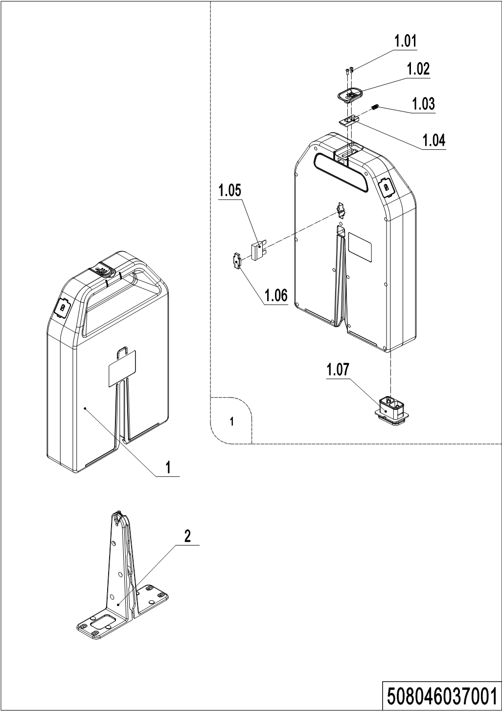

04 Traction Battery (508046037001)
No. | Item Code | Mark | Item Description | Qty. | Substitute | Note
1 | 508037010003 |  | Li Battery24V20Ah | 1 |  | HF
1 | 508037010004 |  | Li Battery24V30Ah | 1 |  | HF
1 | 508037010005 |  | Li Battery24V36Ah | 1 |  | HF
1 | 508037010006 |  | Li Battery24V20Ah | 1 |  | FDE
1 | 508037010007 |  | Li Battery24V30Ah | 1 |  | FDE
1 | 508037010008 |  | Li Battery24V36Ah | 1 |  | FDE
1 | 508037010010 |  | Li Battery24V20Ah | 1 |  | ZJ
1.01 | 910200500011 | 2 | Screw | 2
1.02 | 508098520022 | 2 | Plastic Handle | 1
1.03 | 508098520024 | 2 | Spring | 1
1.04 | 508098520023 | 2 | Fixing Mount | 1
1.05 | 920100200006 |  | Fuse | 1
1.06 | 508098520021 | 2 | Waterproof plug | 1
1.07 | 508098510069 | 2 | Rubber Cover | 1
2 | 508033010020 |  | Battery Rack | 1

05 Indicator holder assembly (508346033501)
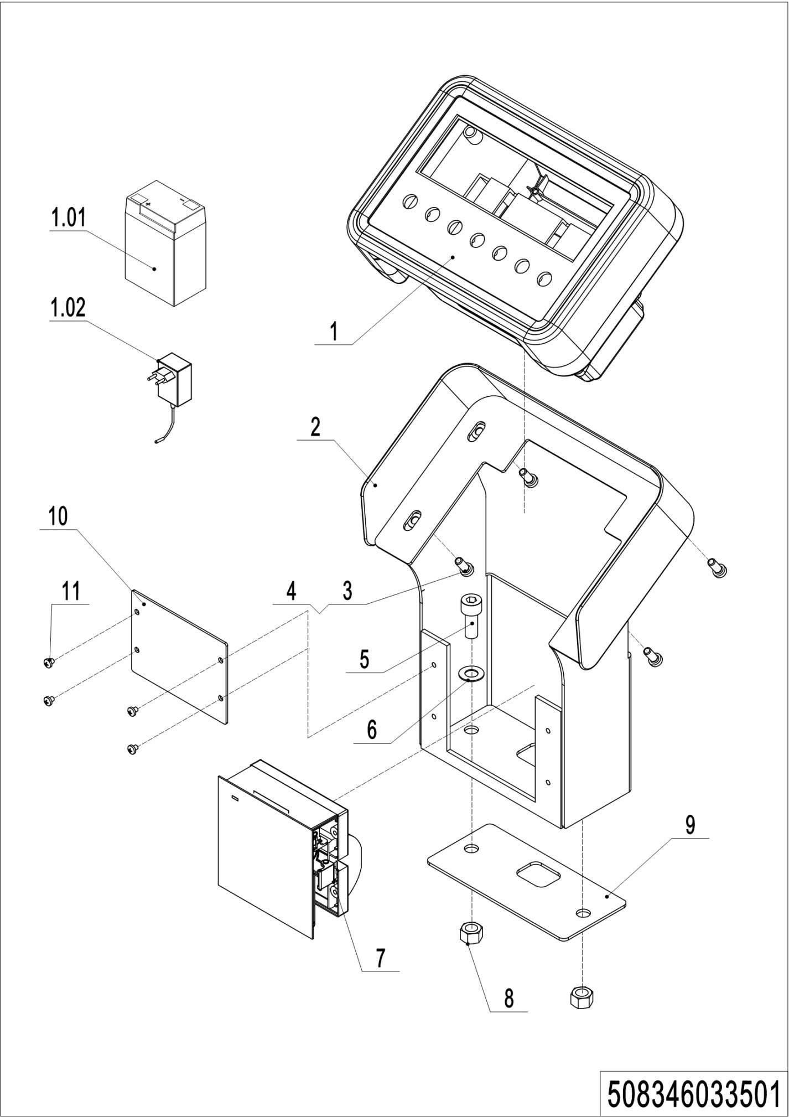
05 Indicator holder assembly (508346033501)
No. | Item Code | Mark | Item Description | Qty. | Substitute | Note
1 | 921100100068 |  | Display | 1 |  | With Printer, CHN
1 | 921100100067 |  | Display | 1 |  | With Printer, ENG
1 | 921100100066 |  | Display | 1 |  | Without Printer, CHN
1 | 921100100064 |  | Display | 1 |  | Without Printer, ENG
1.01 | 920600100109 |  | Battery6V4.5Ah | 1 |  | 6V4.5Ah20HR
1.02 | 921000200467 |  | Charger7.2V1A(Asia-CHN) | 1
1.02 | 921000200468 |  | Charger7.2V1A(Asia-ENG) | 1
1.02 | 921000200469 |  | Charger7.2V1A(USA) | 1
1.02 | 921000200470 |  | Charger7.2V1A(EU) | 1
1.02 | 921000200471 |  | Charger7.2V1A(AUS) | 1
1.02 | 921000200472 |  | Charger7.2V1A(ITA) | 1
1.02 | 921000200473 |  | Charger7.2V1A(SWE) | 1
1.02 | 921000200474 |  | Charger7.2V1A(ISR) | 1
1.02 | 921000200475 |  | Charger7.2V1A(BRA) | 1
1.02 | 921000200476 |  | Charger7.2V1A(ARG) | 1
1.02 | 921000200477 |  | Charger7.2V1A(ZA) | 1
1.02 | 921000200478 |  | Charger7.2V1A(IDA) | 1
1.02 | 921000200479 |  | Charger7.2V1A(ENG) | 1
2 | 508333510000 |  | Mounting Base | 1
3 | 910200500038 |  | Screw | 4
4 | 910400100004 |  | Flat Washer | 4
5 | 910200200057 |  | Screw | 4
6 | 910400100006 |  | Flat Washer | 4
7 | 921100100065 |  | Printer | 1 |  | With Printer
8 | 910300500004 |  | Nut | 4
9 | 508333520002 |  | Mounting Base | 1
10 | 508333520005 |  | Guard Plate | 1 |  | Without Printer
11 | 910200500019 |  | Screw | 4 |  | Without Printer

Chapter 6: Others

01 Labels and Decals-EU (508346047001) 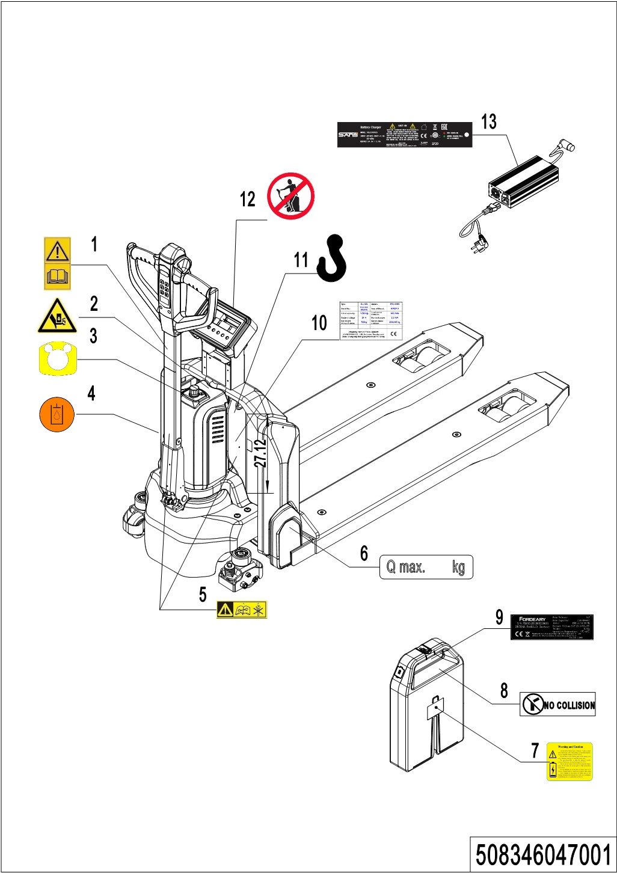
01 Labels and Decals-EU (508346047001)
No. | Item Code | Mark | Item Description | Qty. | Substitute | Note
1 | 941200300002 |  | Label | 1
2 | 508047020007 |  | Label | 1
3 | 508047020000 |  | Label | 1
4 | 941200300003 |  | Label | 1
5 | 508047020004 |  | Label | 2
6 | 941200200009 |  | Label | 2
7 | 508098520025 |  | Label | 1
8 | 508047020002 |  | Label | 1
9 | 508047020009 |  | Label | 1
10 | 508047520002 |  | Truck data plate | 1
11 | 941200300001 |  | Label | 2
12 | 941200100003 |  | Label | 1
13 | 508047520005 |  | Label | 1

02 Labels and Decals-US (508346047002)
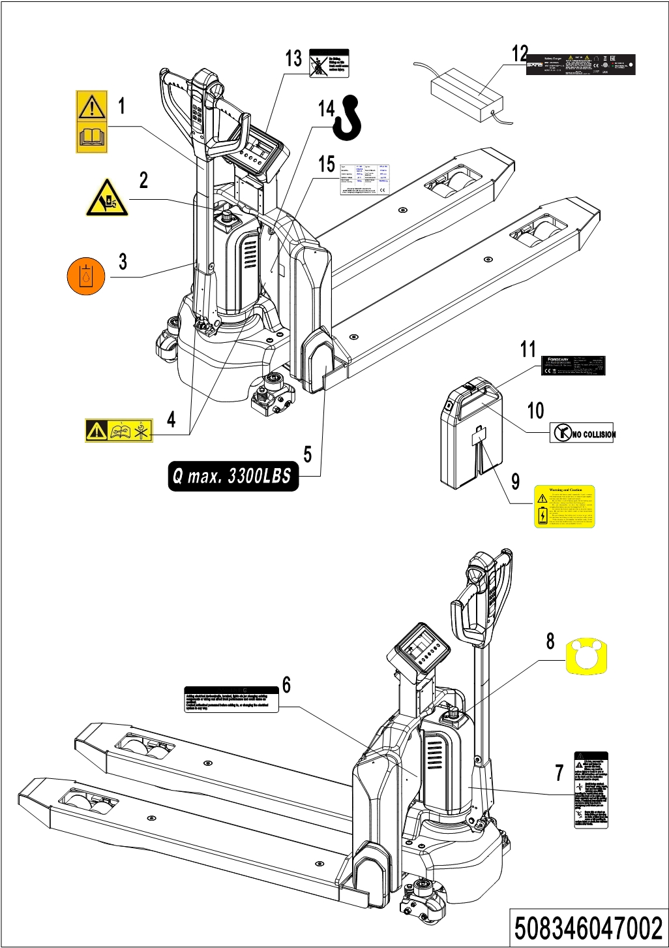
02 Labels and Decals-US (508346047002)
No. | Item Code | Mark | Item Description | Qty. | Substitute | Note
1 | 941200300002 |  | Label | 1
2 | 508047020007 |  | Label | 1
3 | 941200300003 |  | Label | 1
4 | 508047020004 |  | Label | 2
5 | 941200200035 |  | Label | 2
6 | 941200100010 |  | Label | 1
7 | 941200100009 |  | Label | 1
8 | 508047020000 |  | Label | 1
9 | 508098520025 |  | Label | 1
10 | 508047020002 |  | Label | 1
11 | 508047020009 |  | Label | 1
12 | 508047520005 |  | Label | 1
13 | 941200100011 |  | Label | 1
14 | 941200300001 |  | Label | 2
15 | 508047520002 |  | Truck data plate | 1

Appendix

01 Electrical Circuit Diagram(508046045501)
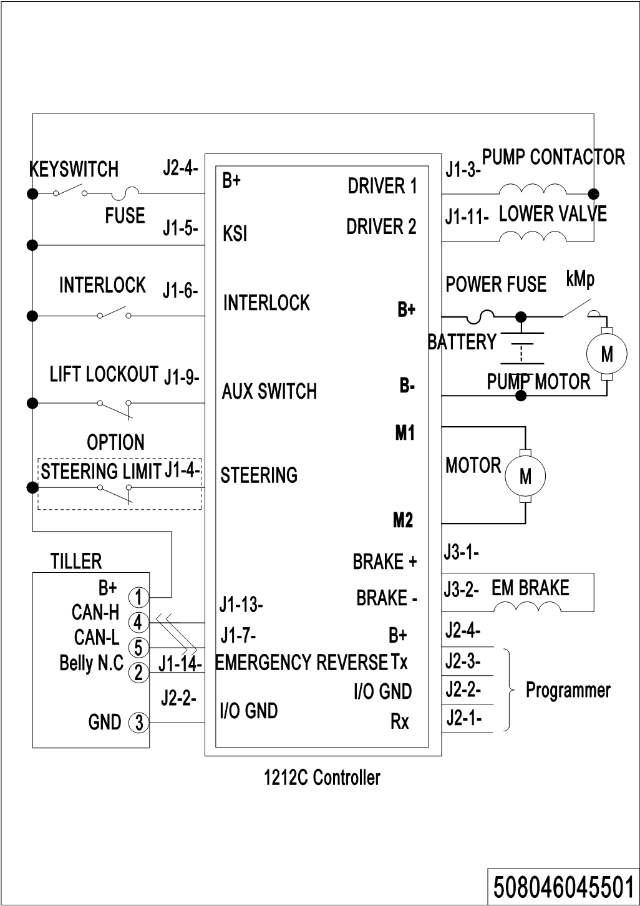

02 Hydraulic Circuit Diagram(508046045502)
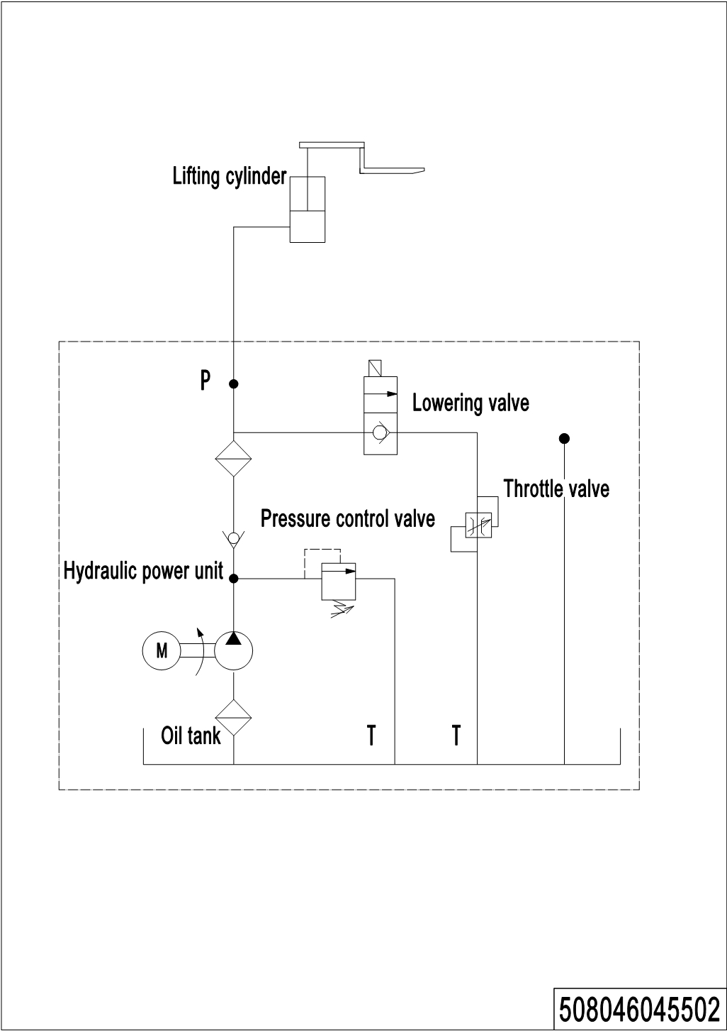

03 Consumable Parts List
No. | Item Code | Item Description | Qty. | Chapter/ Section/ Number
1 | 910700200058 | Bearing | 1 | Chapter 1/01/5
2 | 910700600044 | Bearing | 1 | Chapter 1/01/7
3 | 910700200004 | Bearing | 1 | Chapter 1/02/4
4 | 508098520000 | Carbon Brush | 4 | Chapter 1/02/6.01
5 | 910700200016 | Bearing | 1 | Chapter 1/02/6.03
6 | 508098520003 | Wheel | 1 | Chapter 1/02/8
7 | 508098520008 | Brush | 1 | Chapter 2/01/4.02
8 | 508098510018 | Seal Kit | 1 | Chapter 2/01/10.01
9 | 508598510004 | Seal Kit | 1 | Chapter 2/01/10.03
10 | 940500100097 | Bushing | 2 | Chapter 3/01/14.01Chapter 3/02/14.01
11 | 911200100002 | Oil Cup | 2 | Chapter 3/01/14.02Chapter 3/02/14.02
12 | 940500100083 | Bushing | 8 | Chapter 3/01/14.05Chapter 3/02/14.05
13 | 911200100001 | Oil Cup | 2 | Chapter 3/01/17.06Chapter 3/02/17.06
14 | 508033010001 | Wire Harness | 1 | Chapter 4/01/4
15 | 940500200001 | Bushing | 2 | Chapter 4/01/6
16 | 920200400027 | Proximity Switch | 1 | Chapter 4/01/9
17 | 508011010001 | Gas Spring | 1 | Chapter 4/01/10.3
18 | 505638520039 | Running Pulley | 2 | Chapter 4/03/1.02
19 | 508098510049 | Wheel | 2 | Chapter 4/03/2
20 | 940500200038 | Bushing | 4 | Chapter 4/03/2.01
21 | 910700200019 | Bearing | 8/4 | Chapter 4/03/2.04
22 | 940300300005 | WheelΦ80x70 | 4 | Chapter 4/03/2.05
23 | 940500100088 | Bushing | 4 | Chapter 4/03/2.09
24 | 508098510050 | Wheel | 2 | Chapter 4/03/3
25 | 940300300023 | WheelΦ80x93 | 2 | Chapter 4/03/3.01
26 | 910700200018 | Bearing | 2 | Chapter 4/04/6.1
27 | 940300300017 | WheelΦ80x30 | 1 | Chapter 4/04/6.2
28 | 508098510047 | Spring Components | 2 | Chapter 4/04/7
29 | 508033010010 | Wire Harness | 1 | Chapter 5/01/1
30 | 508033010003 | Wire Harness | 1 | Chapter 5/01/2

No. | Item Code | Item Description | Qty. | Chapter/ Section/ Number
31 | 508033010001 | Wire Harness | 1 | Chapter 5/01/3
32 | 508033010005 | Wire Harness | 1 | Chapter 5/01/4
33 | 508033010004 | Wire Harness | 1 | Chapter 5/01/5
34 | 508033010006 | Wire Harness | 1 | Chapter 5/01/6
35 | 508033010018 | Wire Harness | 1 | Chapter 5/01/6
36 | 508033010007 | Wire Harness | 1 | Chapter 5/01/7
37 | 508033010000 | Wire Harness | 1 | Chapter 5/01/8
38 | 508033010009 | Wire Harness | 1 | Chapter 5/01/8
39 | 920200100015 | Emergency Button | 1 | Chapter 5/02/1
40 | 920200300012 | Microswitch | 1 | Chapter 5/02/7
41 | 920100200006 | Fuse | 1 | Chapter 5/04/1.05

